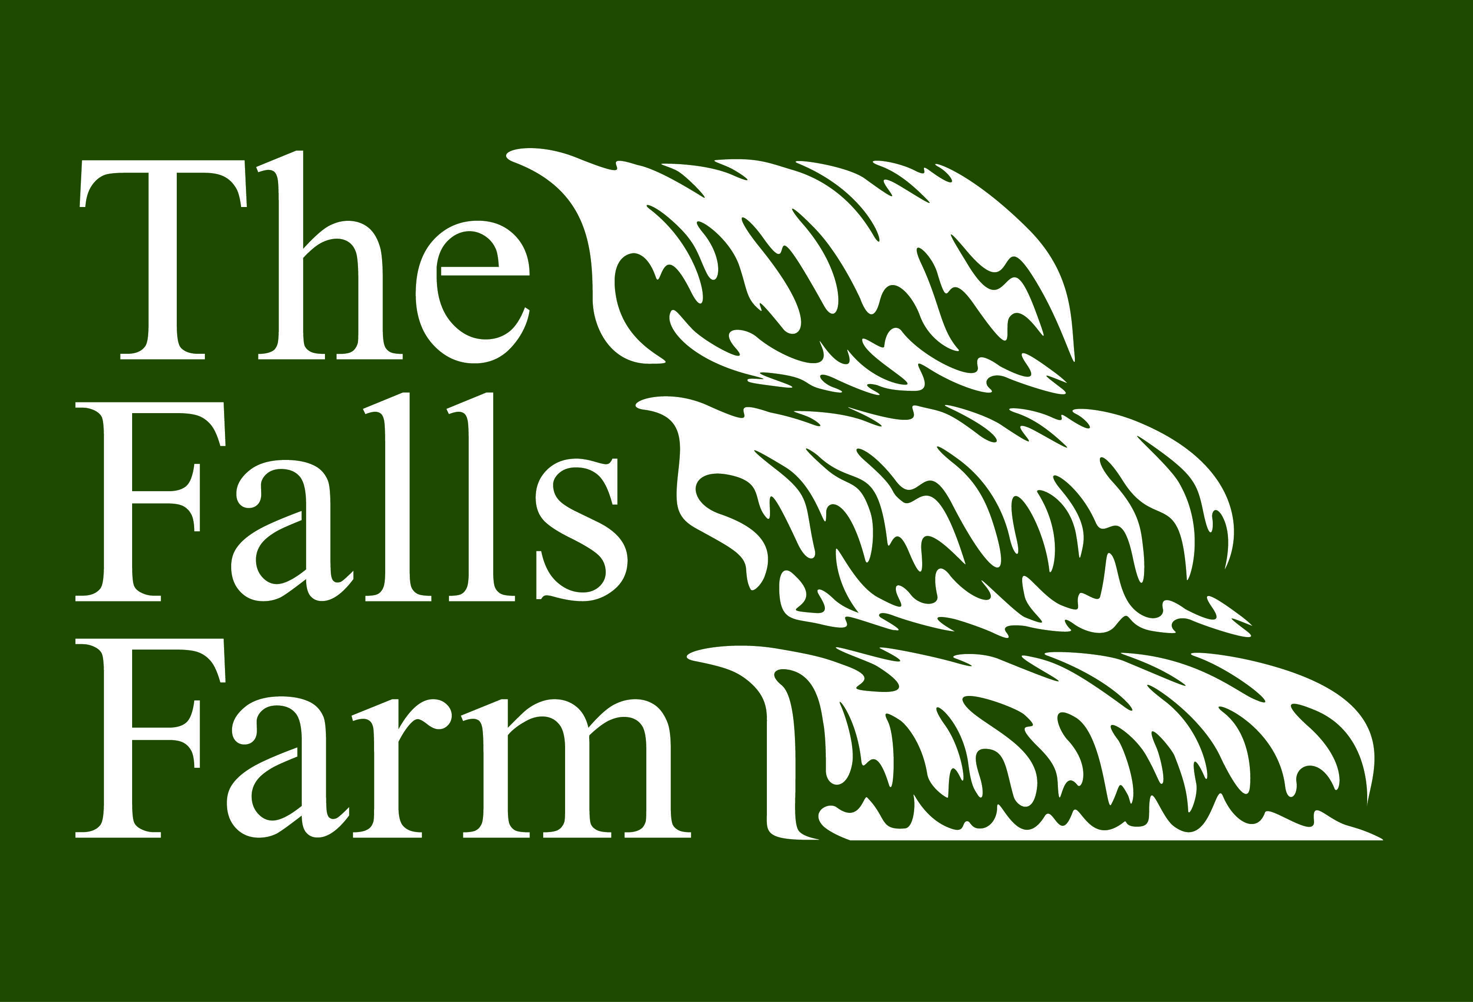
The Falls Farm
190 Jackson Rd Rockmart, GA 30153
thefallsfarmrockmart@gmail.com 678-689-3391 or 360-600-8715

Beef Order Info

Here’s How This Works:
The Falls Farm wants you, our customer, to have a great experience from start to finish with your custom beef order. That means that we plan on giving you all the information you need up front to ensure your happiness with our product.

Our Cows:
The beef you will be enjoying was born and raised on The Falls Farm. Our cows are primarily grass-fed with brewer’s grain supplementation in the winter. They are not given any growth hormones or antibiotics. We take great pride in the care these cows receive during their time on our farm.

Harvesting of Cows:
Our goal is to harvest your steer when it reaches 1000-1300lbs. By harvesting your steer between this weight range we can guarantee a tender and flavorful product. We harvest each steer on a case-by-case basis in order to ensure the highest quality meat. Once your cow is harvested it will take about 7-10 business days to receive your meat; it will be vaccum packaged. Your custom order will include: ground meat, steaks, roasts, stew pieces, etc.

What is My Cost?:
The Falls Farm charges our customers $4.00/lb on the hanging weight of the cow. The Falls Farm will cover the processor’s costs including the slaughter fee. If you’d like we can set up a payment plan for your order. By purchasing a quarter, half, or whole of beef you will be saving a substantial amount compared to buying retail cuts individually.
Example of fee schedule for 1000lb live steer:
1000lb Steer
Hanging Weight (approx 60%) = 600lbs
600lbs @ $4.00 = $2400.00 cost
Packaged Meat (65-70% of hanging wgt) = 600 x .65 = 390lbs (but can be as high as 420lbs)
Quarter of Beef = approx. $600 and 100lbs of meat

How do I Place an Order?:
Please fill out a Beef Order Form and return it to us via email, mail or in-person. We will require a $100 non-refundable deposit at the time of your order. The remainder of your balance will be due once you pick up your beef. Your custom cut sheet will be taken just prior to harvesting your cow. Please do not hesitate to ask us any questions you might have about cuts, prices, acceptable forms of payment, etc.

Thank you and happy ordering!

Bennett & Rebecca Jacobs
The Falls Farm
190 Jackson Rd Rockmart, GA 30153
thefallsfarmrockmart@gmail.com 678-689-3391 or 360-600-8715

Beef Order Form

Name: ___________________________________ Date: ________________________
Address: _________________________________ Phone: ______________________
City & State: _________________________________________
Email: ______________________________________________

My order consists of a:

_____ Whole Cow _____ Half Cow _____Quarter Cow

*Once we get closer to the processing date we will email you a custom order form so that you can personalize the cuts of beef you receive.

Here’s an example of a whole and quarter cow order:

Whole Quarter

1000lb live cow 1000lb live cow
600lb hanging weight x $4.00/lb = $2400.00 150lb (600/4) hanging weight x $4.00 = $600.00
Total lbs of meat: 390lbs – 420lbs Total lbs of meat: 97.5lbs – 105lbs

*Please keep in mind that your cost will vary depending on the final weight of the cow.

